

DHD WEB GUIDELINE

Knowledge Transfer

Friday, 13 February 2026 at 10:00 - 12:00

Login Page
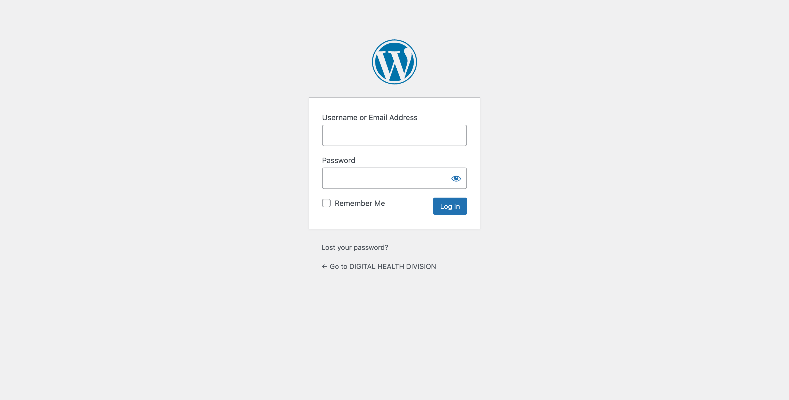

The URL: http://mohdhd-dev.entomo.co/wp-admin

Credentials of Administrator
Username: user
Password: H=NB0c=Y+X+l

Credentials of Editor
Username: drvivek
Password: icPaR7S#%75

Dashboard Admin
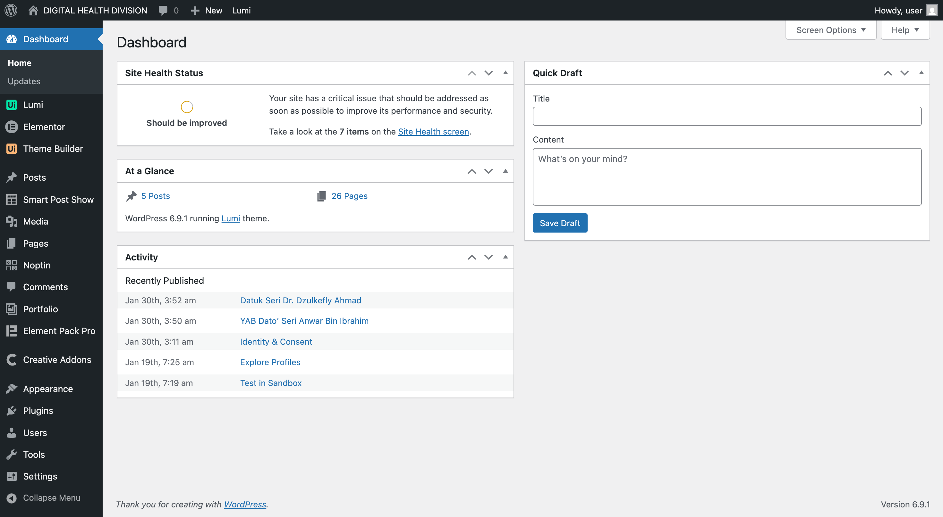
Admin will have a full access including the Theme customization, add/remove plugin, create new user and other function despite of administrative the website.

Dashboard Editor
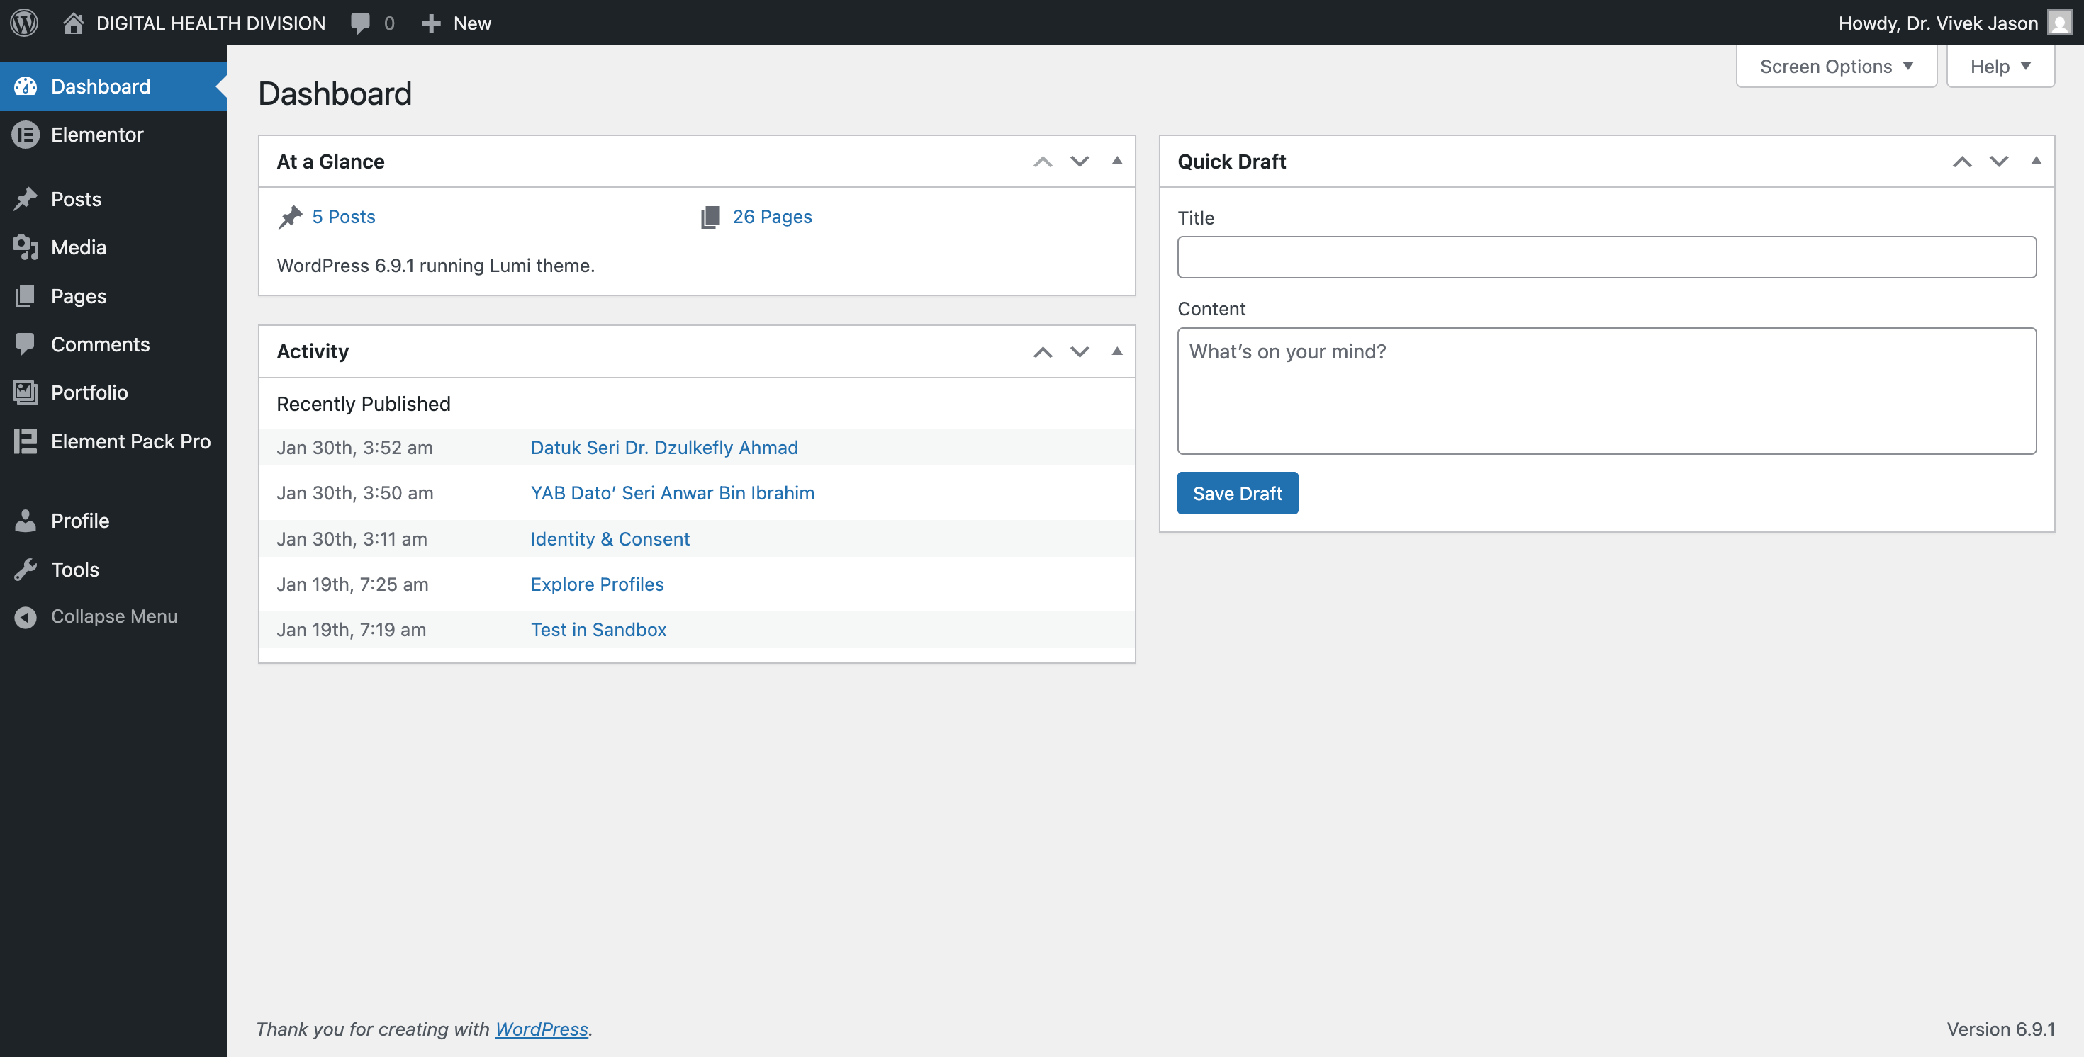
Editor role will have lesser functionality to edit the website content, create new post and create new page.

Admin Module
LUMI THEME
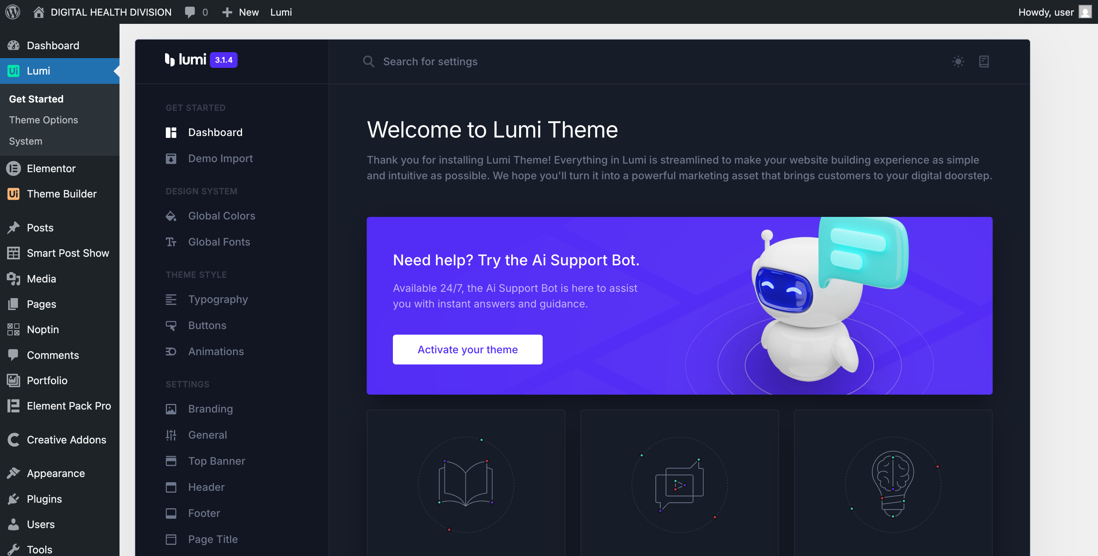

PAGES

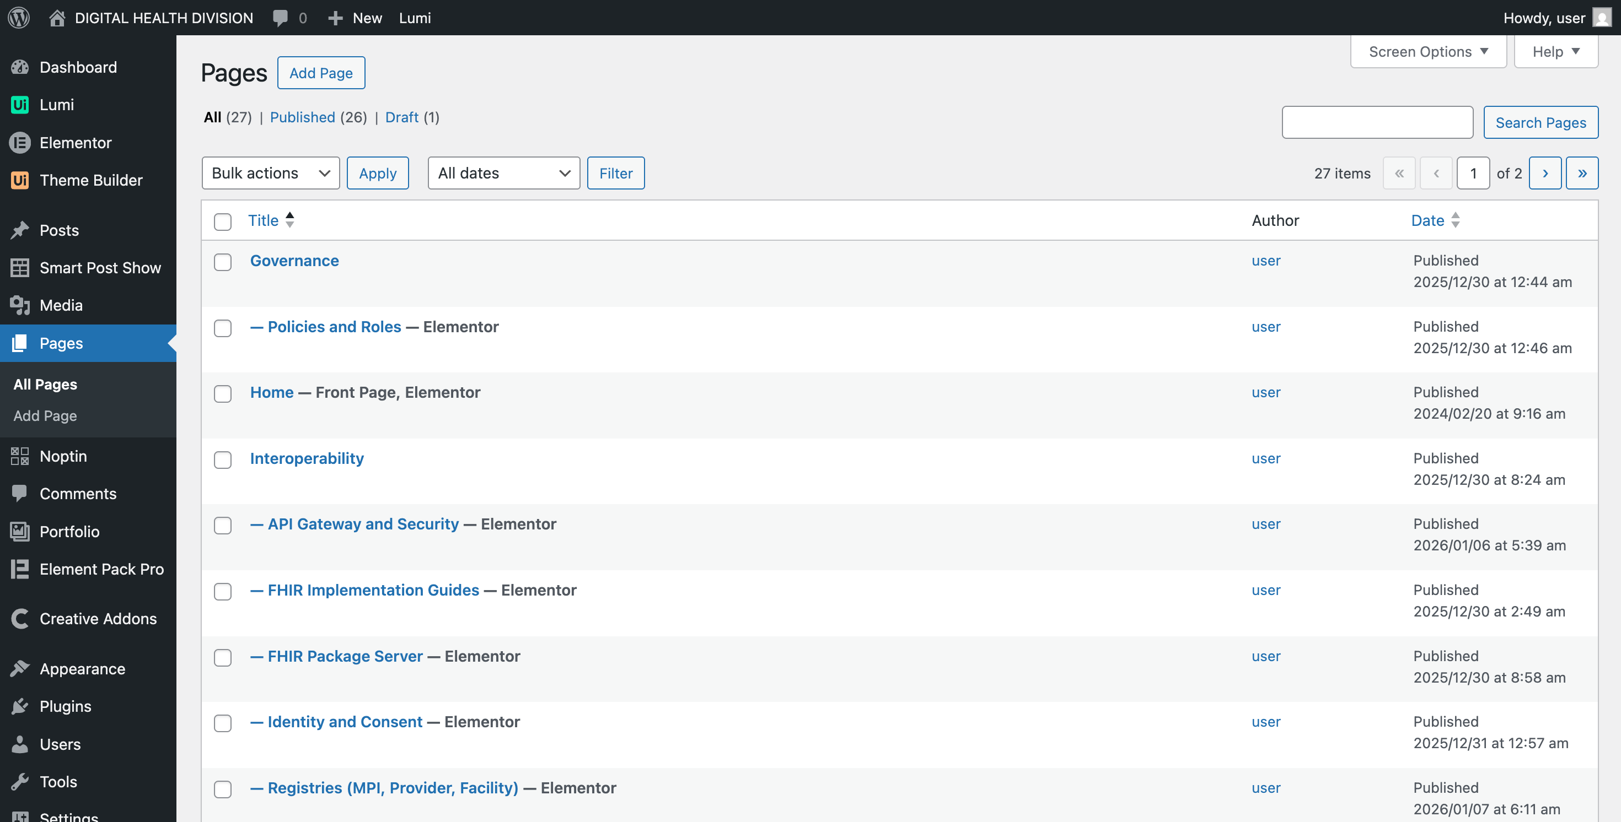

By default, has 20 pages ready built which 6 pages was Parent Page such as Home, Vision, Governance, Interoperability, Resource, Portals, Status.

CREATE / EDITING PAGES

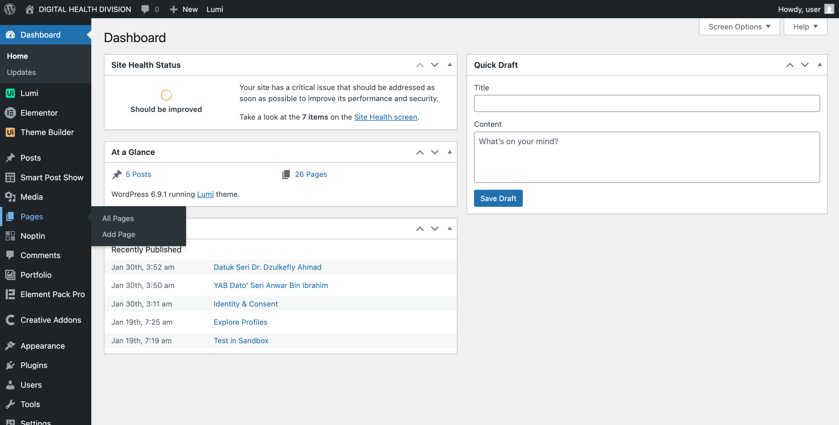
The easiest, fastest and safest way is to duplicate the page from the existing pages.

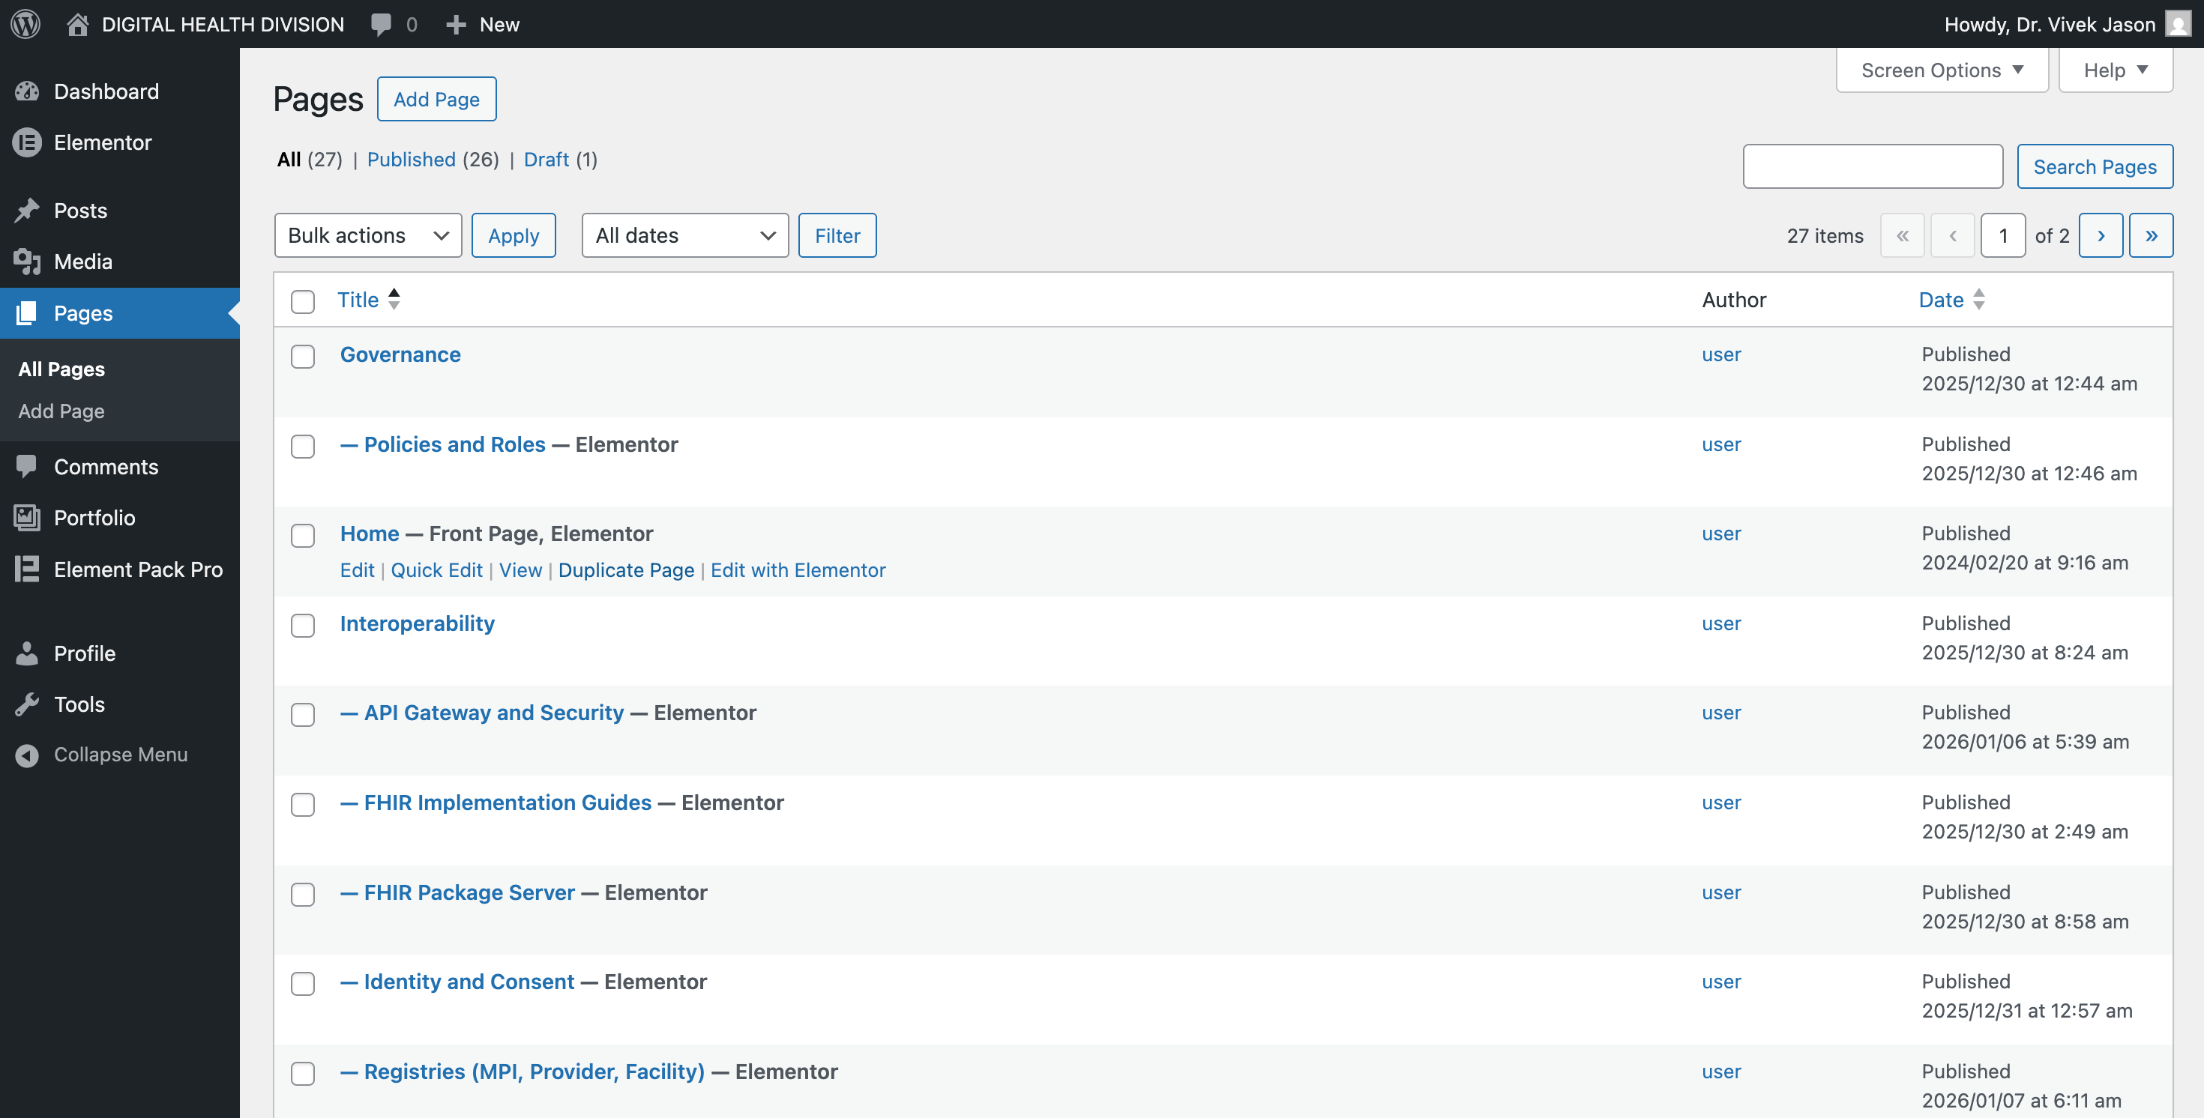

Click on Duplicate Page
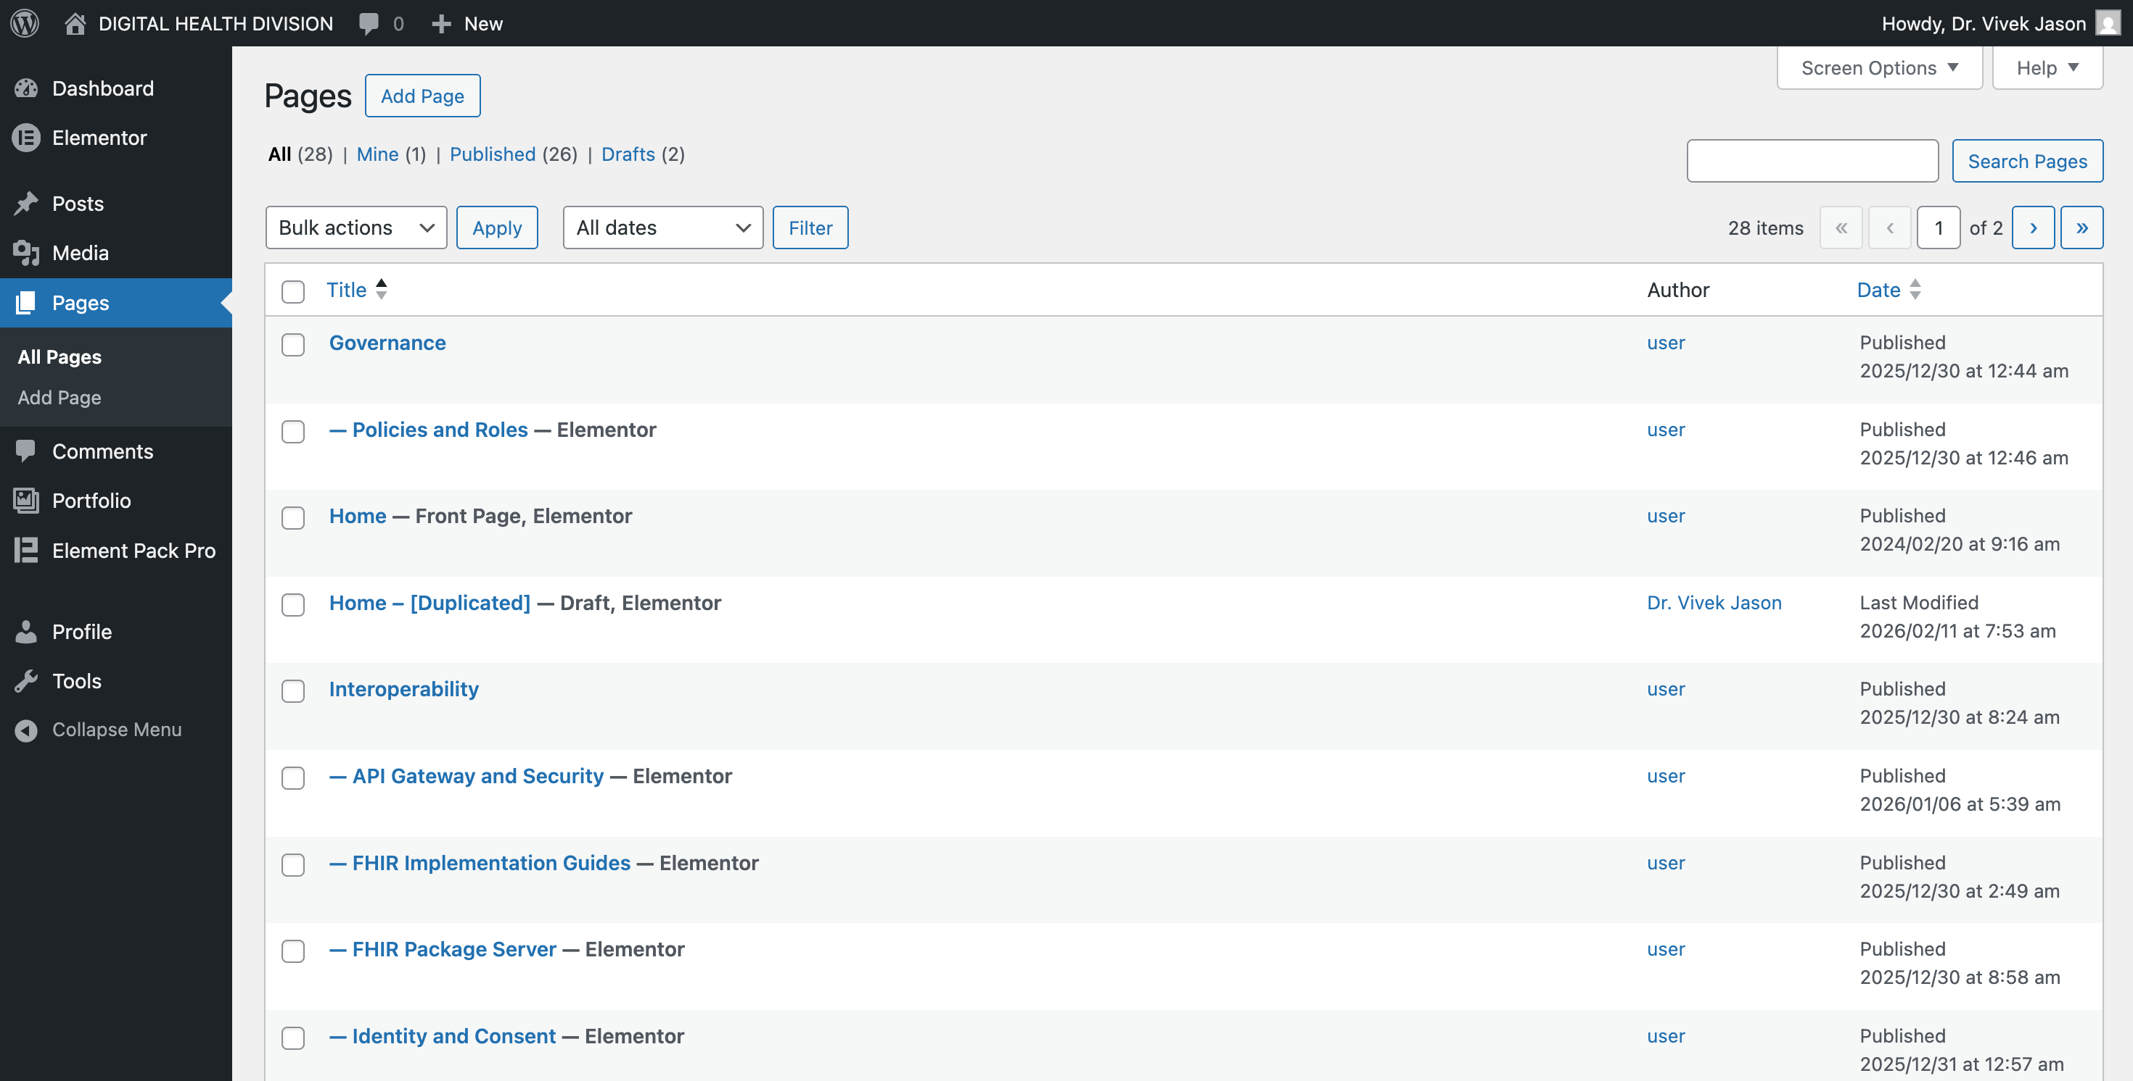

A new page [Duplicated] will be created

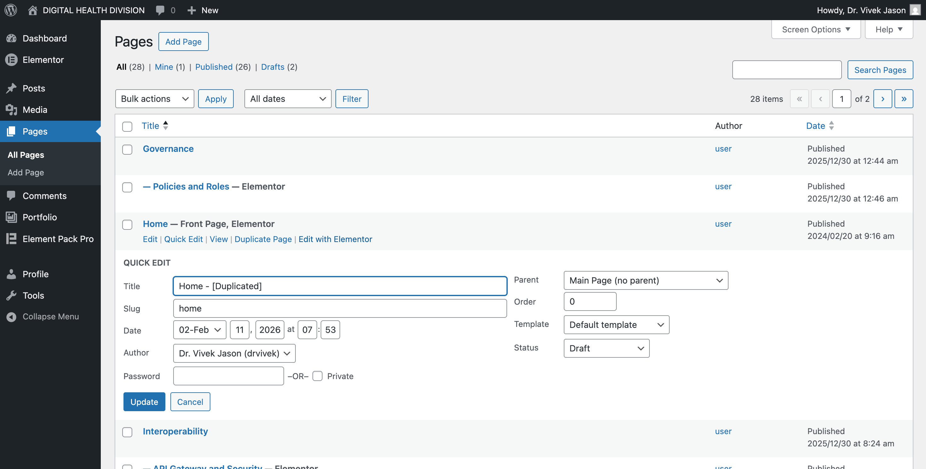

Click on Quick Edit to change the page name (New Pages), the parent (Select Governance) & status (either draft or publish) as per now leave it as draft then click Update button.

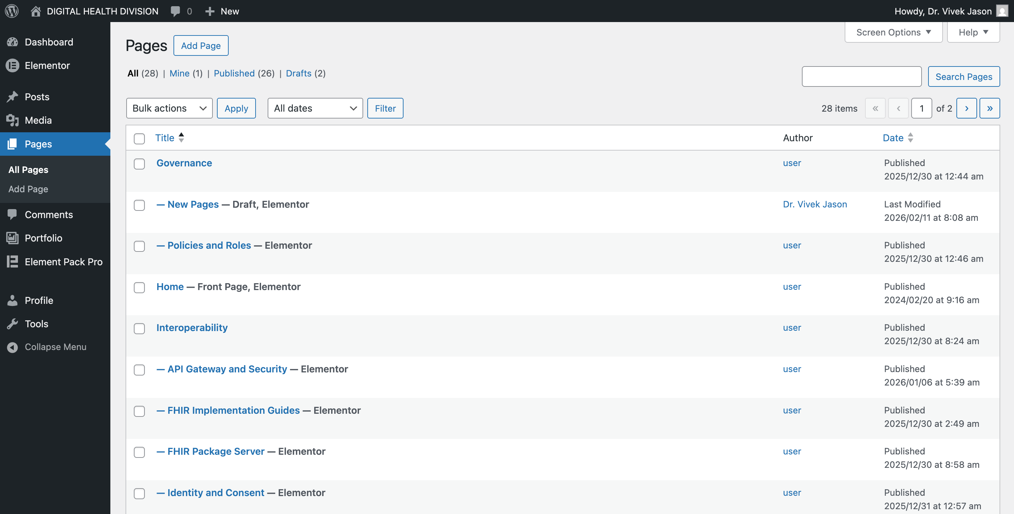

Refresh the page and the new page will be created.

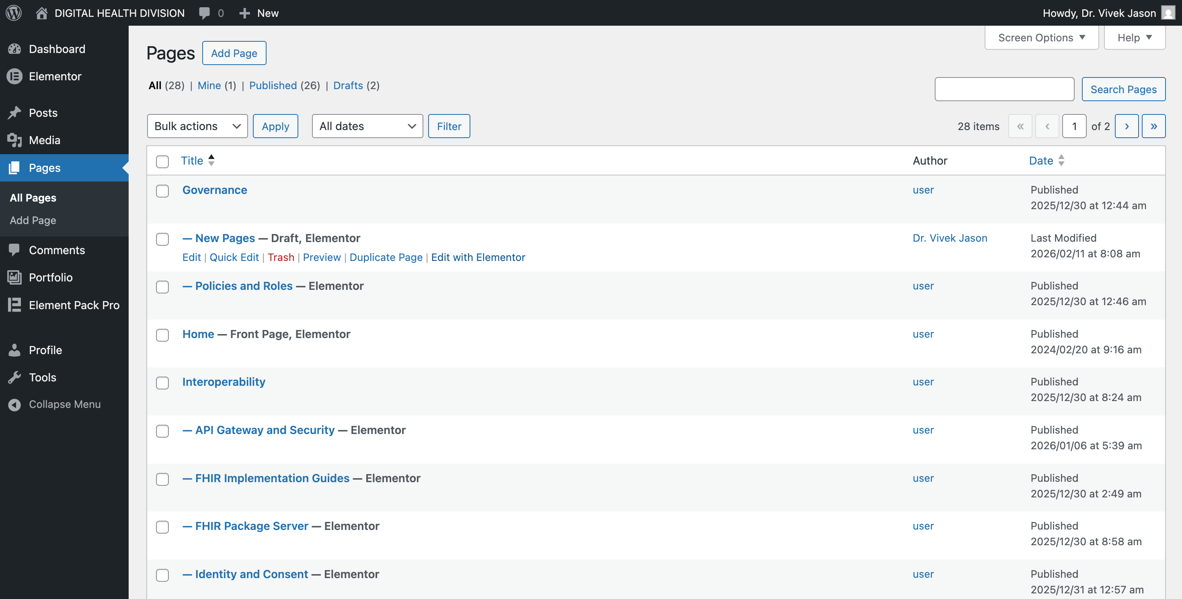

Then click on Edit with Elementor.

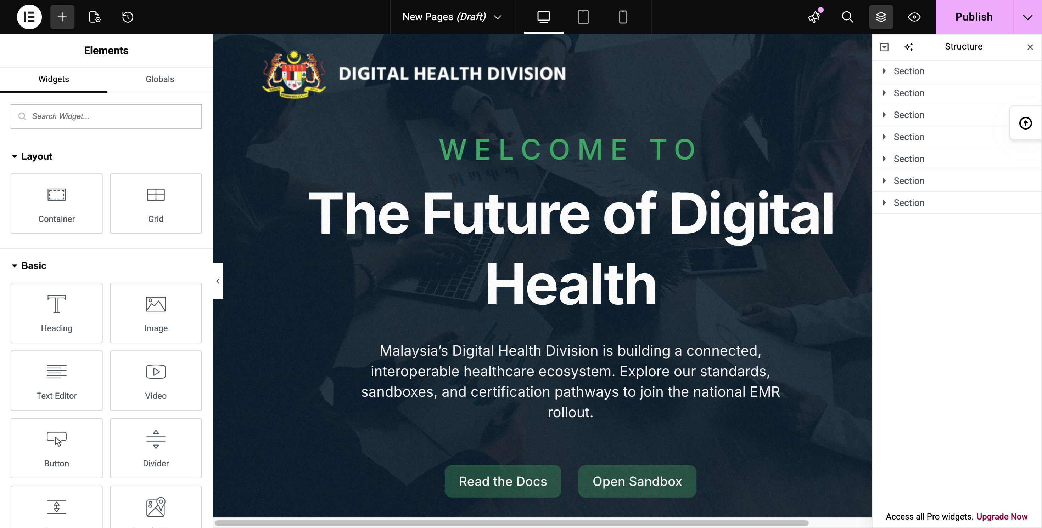
The Elementor page will be open. Edit the page as needed then click Publish to publish the page.

IMPORTANT NOTES

Update Post
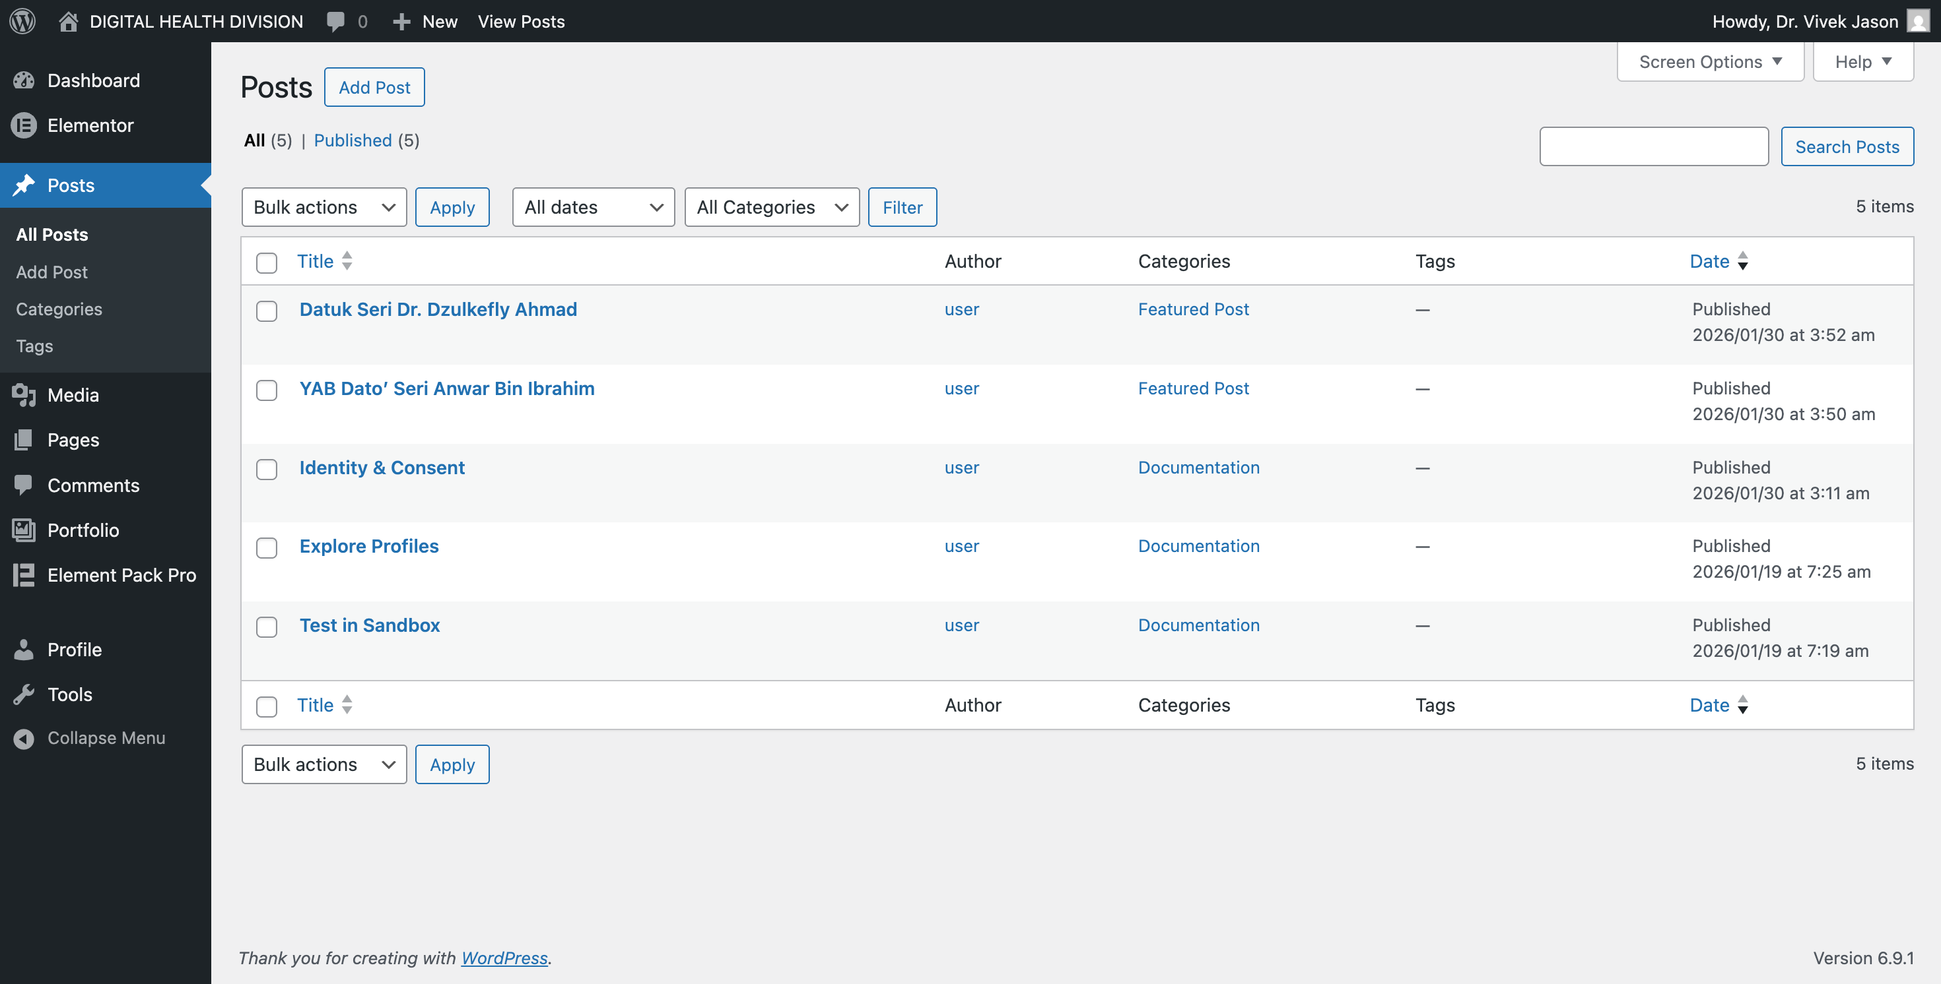

By default, already has 2 (two) featured post and 3 (three) documentation post. Editor may add the new post later, make sure to select and tick the correct post category provided.

Type of Post Category
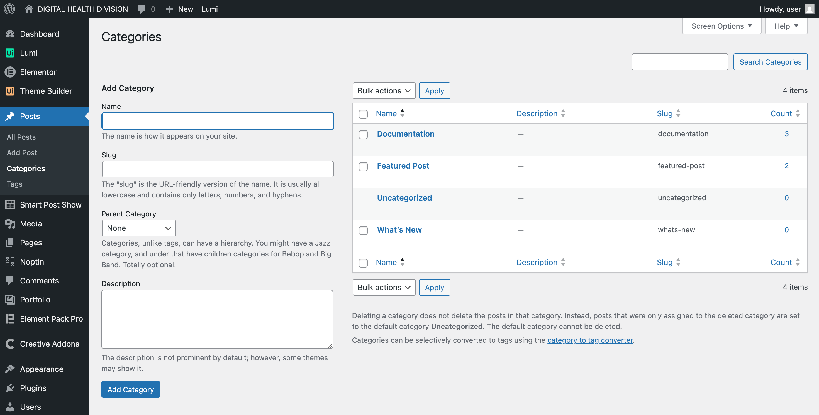

Featured Post
- Used to update the featured post displayed on Homepage
Documentation
- Used to update the featured post displayed in Next Step section on Resource > Documentation Page
What’s New
- Used to update the what’s new section displayed on Homepage
Uncategorized
- It’s a default WordPress category

Create New Post
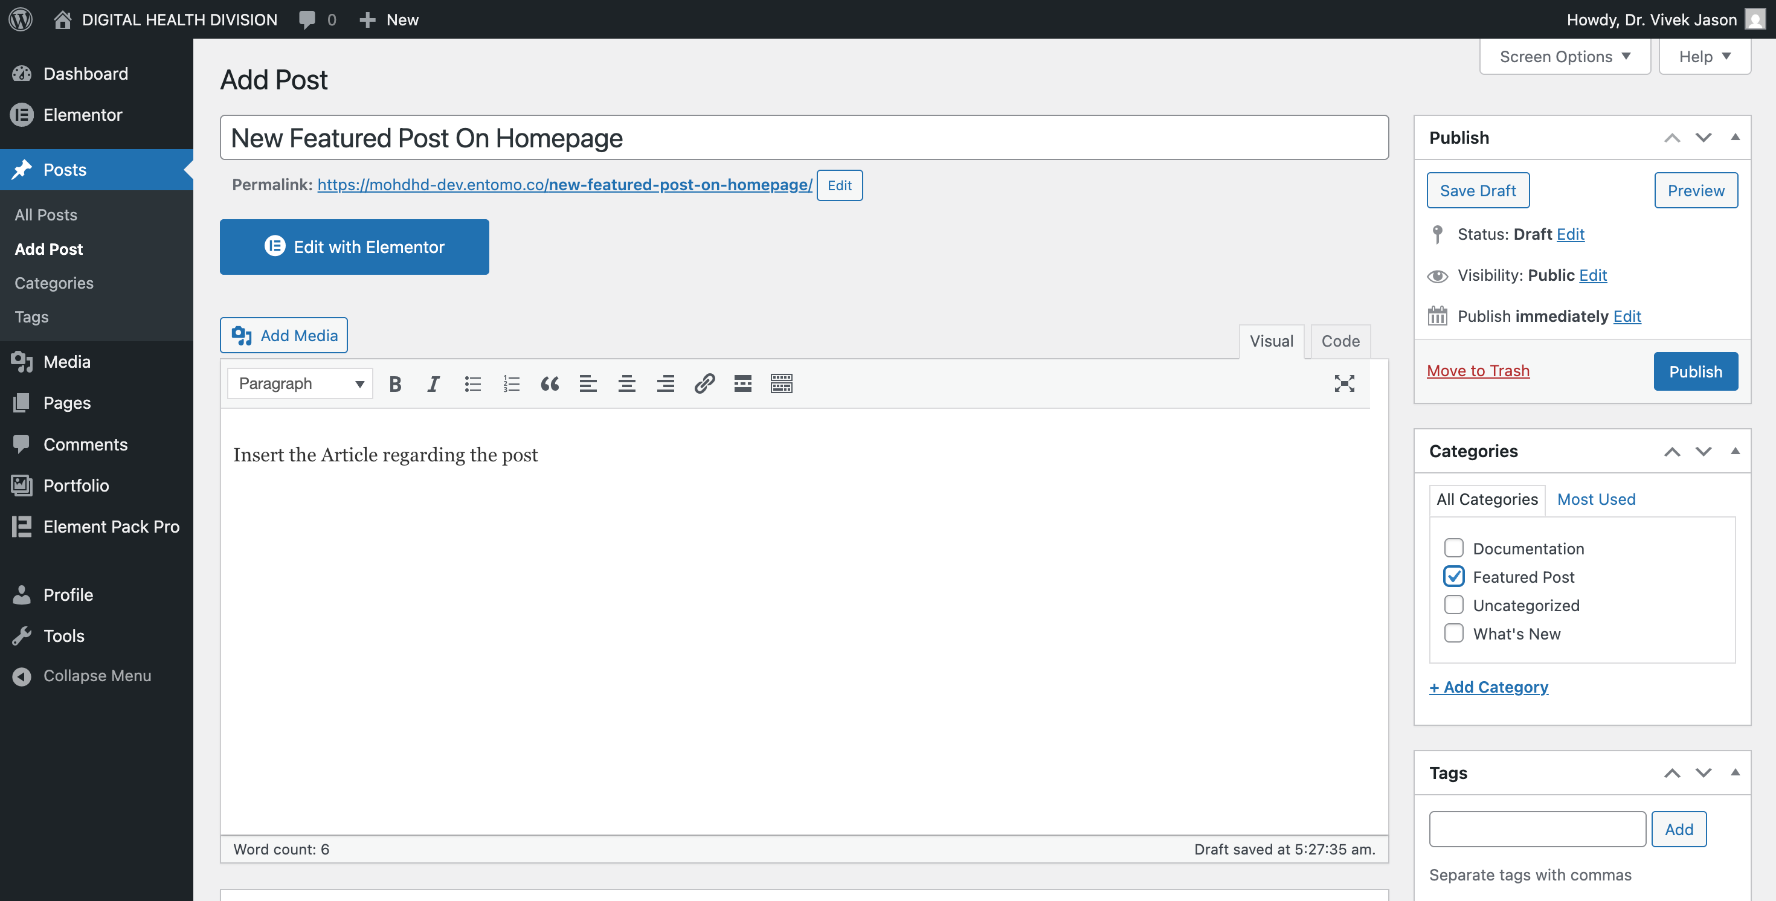
3
2
1

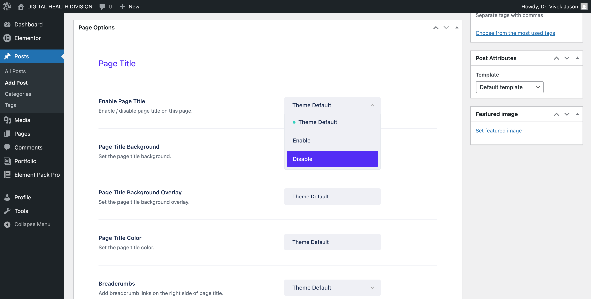
5

4

Step by step instruction:

- Insert the post title
- Enter the full post article
- Tick the post category (most important)
- Set page option (Enable Page Title) to Disabled
- Set Featured Image if applicable (Upload)

Upload Image
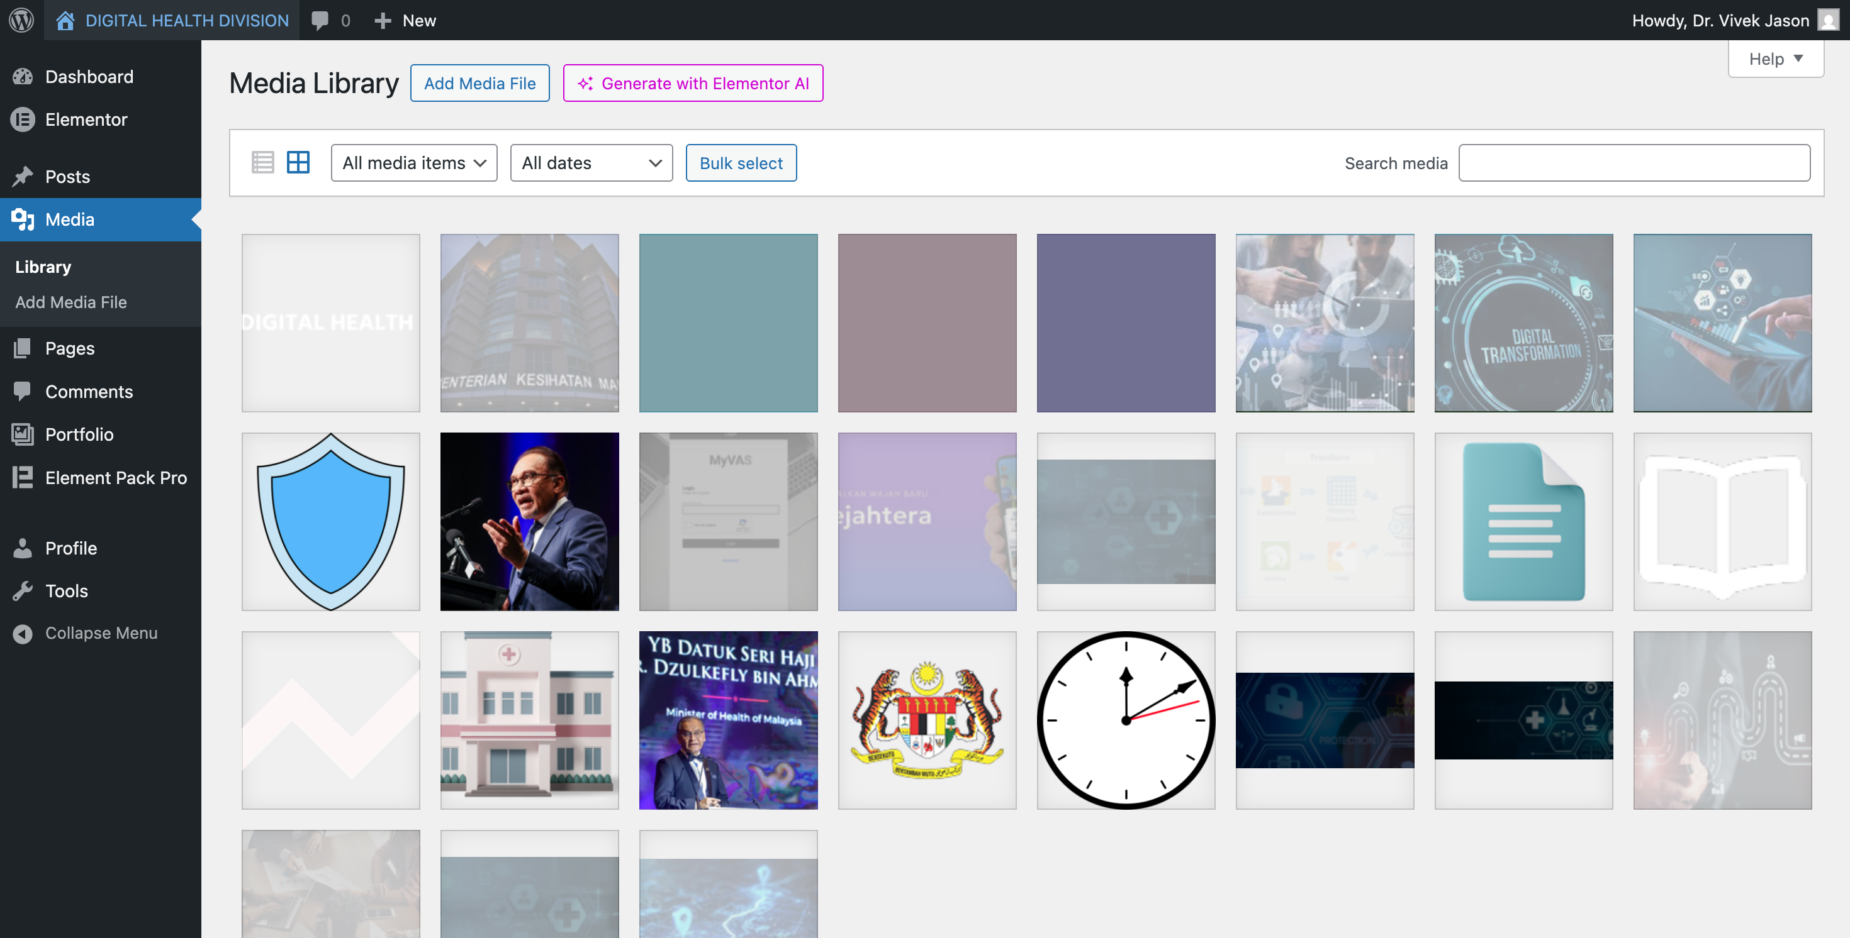

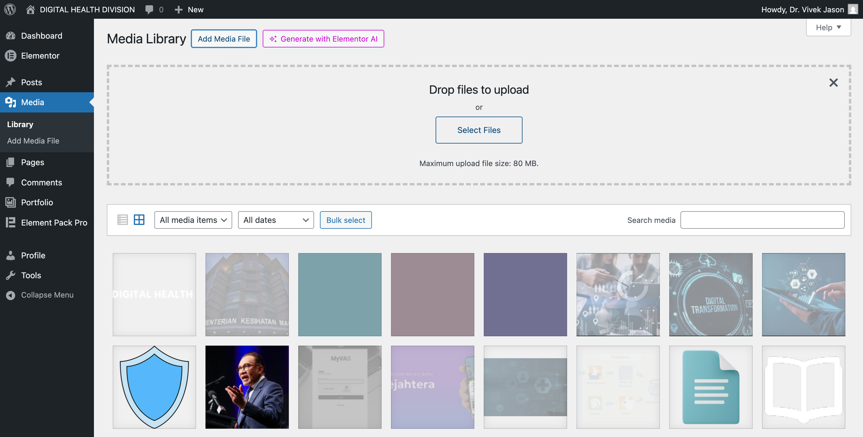

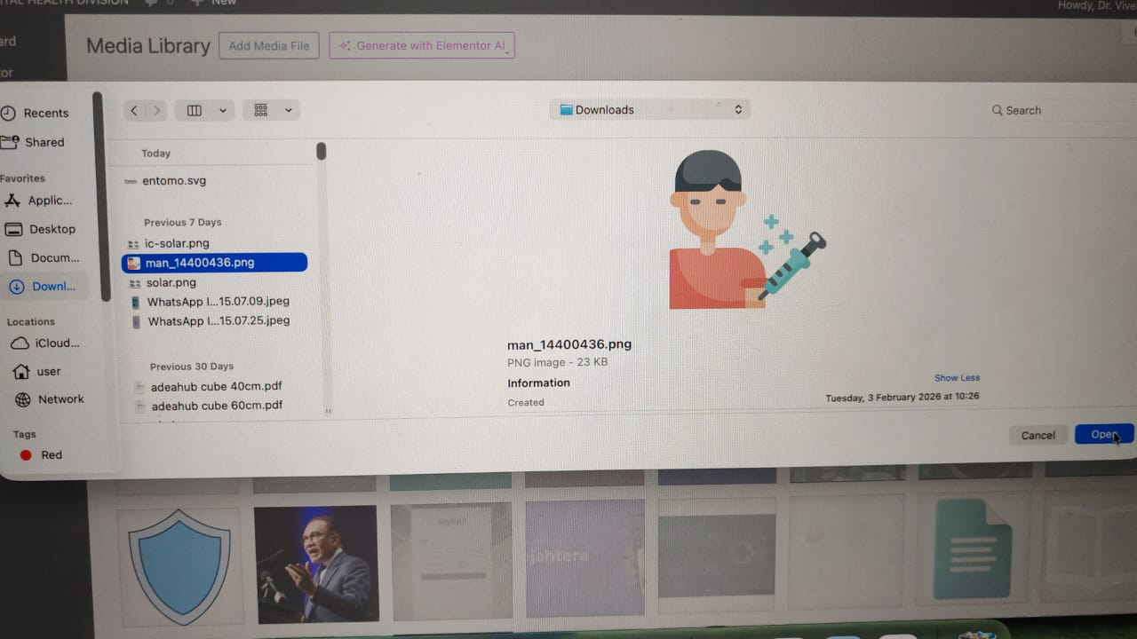

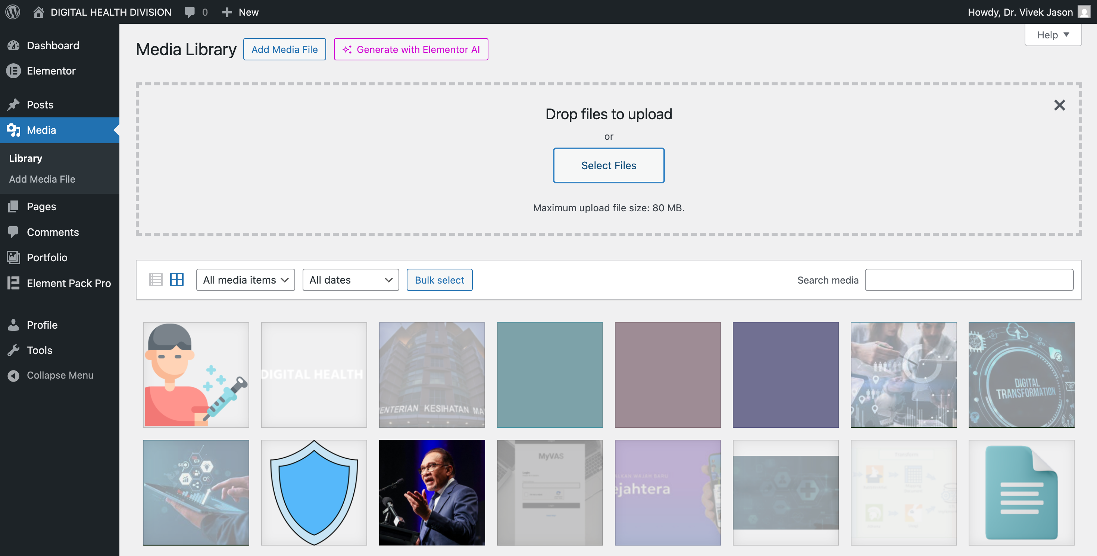

Image can be upload anytime anywhere by a click of a button. Not necessarily need to upload here. If bulk image upload needed, here is the perfect place. Just click the Add Media File button, browse the file location and click Open.

APPENDIX

THEME CSS CUSTOMIZATION (Please DO NOT CHANGE)
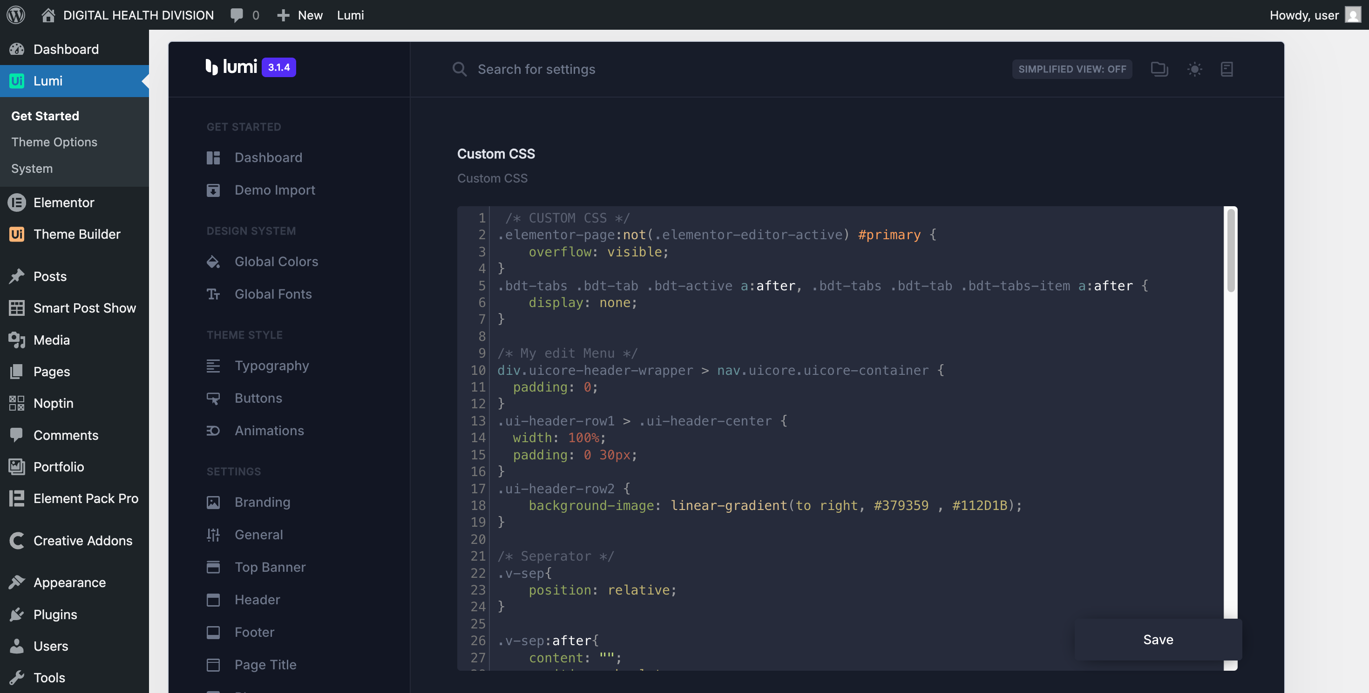

/* CUSTOM CSS */
.elementor-page:not(.elementor-editor-active) #primary {
overflow: visible;
}
.bdt-tabs .bdt-tab .bdt-active a:after, .bdt-tabs .bdt-tab .bdt-tabs-item a:after {
display: none;
}
/* My edit Menu */
div.uicore-header-wrapper > nav.uicore.uicore-container {
padding: 0;
}
.ui-header-row1 > .ui-header-center {
width: 100%;
padding: 0 30px;
}
.ui-header-row2 {
background-image: linear-gradient(to right, #379359 , #112D1B);
}

/* Seperator */
.v-sep{
position: relative;
}
.v-sep:after{
content: "";
position: absolute;
top: 8%;
height: 85%;
width: 10px;
right: 0;
transform: translateX(50%); /* PUSH divider into center gap */
background: linear-gradient(to bottom, #1D4B68, #3994CEB2);
pointer-events: none;
}
.bdt-static-body-row-cell-wrap {
display: flex;
flex-direction: row-reverse;
width: 100%;
justify-content: center;
gap: 10px;
}
.bdt-static-body-row-cell-icon {
display: flex;
align-content: center;
align-items: center;
justify-content: center;
flex-wrap: wrap;
}
#space-between > a > span {
display: flex;
justify-content: space-between;
}
#trans-bg > .ui-e-carousel > .swiper-wrapper > .swiper-slide > .ui-e-item {
background: transparent;
}
.editor-styles-wrapper {
background: #ffffff !important;
}
/* Featured Post */
.sp-pcp-post .sp-pcp-title, .sp-pcp-post .sp-pcp-title a {
font-size: 40px;
line-height: 44px;
font-weight: bold;
color: #ffffff;
}
.sp-pcp-post-content {
font-size: 20px !important;
line-height: 24px !important;
color: #ffffff !important;
}
.pcp-post-thumb-wrapper {
border: solid 5px #194540 !important;
border-radius: 50px !important;
}
.sp-pcp-post {
gap: 50px !important;
}
.sps-list-layout .sp-pcp-post.left-thumb .pcp-post-thumb-wrapper {
max-width: 50% !important;
}

.sps-list-layout .sp-pcp-post.left-thumb .sp-pcp-post-details {
max-width: calc(50% - 20px) !important;
height: 100% !important;
display: flex;
flex-direction: column;
justify-content: center;
}
.sp-pcp-post.left-thumb {
display: flex;
height: 100%;
align-items: center;
}
@media (max-width:768px) {
.sp-pcp-post {
display: flex !importan;
flex-direction: column !important;
}
.sps-list-layout .sp-pcp-post.left-thumb .pcp-post-thumb-wrapper {
max-width: 100% !important;
}
.sps-list-layout .sp-pcp-post.left-thumb .sp-pcp-post-details {
max-width: 100% !important;
}
}
.sp-pcp-row > div:not(:first-child) > .sp-pcp-post {
display: flex;
flex-direction: row-reverse;

.sp-pcp-post-details {
text-align: right;
}
}
.pcp-readmore-link {
color: #ffffff !important;
}
.zero-footer ul {
padding: 0;
margin: 0;
}

CUSTOM JS FOR FILTERING DOCUMENTATION POST
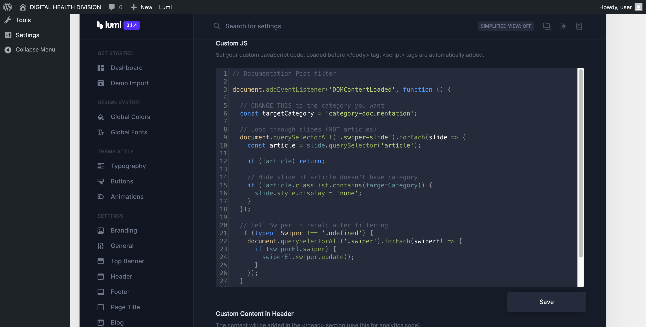

// Documentation Post filter
document.addEventListener('DOMContentLoaded', function () {
// CHANGE THIS to the category you want
const targetCategory = 'category-documentation';
// Loop through slides (NOT articles)
document.querySelectorAll('.swiper-slide').forEach(slide => {
const article = slide.querySelector('article');
if (!article) return;
// Hide slide if article doesn't have category
if (!article.classList.contains(targetCategory)) {
slide.style.display = 'none';
}
});
// Tell Swiper to recalc after filtering
if (typeof Swiper !== 'undefined') {
document.querySelectorAll('.swiper').forEach(swiperEl => {
if (swiperEl.swiper) {
swiperEl.swiper.update();
}
});
}
});

